Data Modelling
Database: Database is nothing but an organized form of data for easy access, storing, retrieval, and managing of data. This is also known as structured form of data which can be accessed in many ways.
Data Modelling is the process that analyze and define the data requirements needed to support the business process within the scope of information systems.
Data Model:
Data model is the conceptual representation of structure and behavior of data and they are very useful in communicating the business rules.

What is Entity: Entity is the place, person, object, resource, concept, event, activity which will collect the data
Customer, product, doctor, patient, department, organization, student, subject, professor
Attributes are characteristics of entity, describes an entity, give meaning to an entity.
Relationship: Association among one or more entities.
Employer to employer,
Each employee belongs to a department,
A particular work item is assigned to the technician for particular customer in a particular location. So here the work assignment is the relation by customer, technician, location, work item.
Employee and Department : with single line on both sides: means each employee must be working in one department and each dept must be having one emp working
Second scenario with zero added at emp: each employee must be working in one dept and each dept may have one emp working (zero or one)
Third scenario : (with three arrow lines added at emp) each emp must be working in one dept and each dept has one or more emp working.
Fourth scenario: (with three lines and one and zero added ) each emp must be working in one dept and each dept has zero or one or more employee working so here min cardinality is 0 and max cardinality is more.
Notation types: Information engineering , barker notation, IDEF1X , UML.

Logical : Logical model does not have any database bindings. We do not get any oracle specific objects .

Identifying : Child cannot exist without the parent and in database point of view it is defined as existence of a row in a child table depends on a row in the parent table
Non Identifying : child may exist without parent . it is optional or mandatory which means foreign column allows Null or Dis allowes Null.

Select *from employee where salary = (select max(salary) from employee);---return record with highest salary
Select max(salary) from employee where salary < (select max(salary) from employee);-- return second highest salary
Or
Select max(salary) from employee where salary NOT IN (Select max(salary) from employee);
Select *from employee where employee_id between 2003 to 2008;-- return range of employees between id.
Return employee name , highest salary and department ;
Select e.first_name ,e.last_name .e.salary,d.department from employee e JOIN d.department ON e.department_id=d.department_id where salary IN (Select max(salary) from employee);

Return employee name , highest salary for each department ;
Select e.first_name ,e.last_name .e.salary,d.department from employee e JOIN d.department ON e.department_id=d.department_id where salary IN (Select max(salary) from employee group by department_id);
Delete duplicates rows from the table :
Delete from employee where rowid NOT IN (Select min (rowid) from employee group by col1,col2,col3);
Add Primary Key:
Alter table employee ADD primary key (id);

ONCEPTUAL DATA MODEL
This ER model establishes a broad view of what should be included in the model set. Conceptual data models:
- Include important entities and the relationship between them.
- Do not specify attributes.
- Do not specify primary keys.
Conceptual ERDs can be used as the foundation for logical data models. They may also be used to form commonality relationships between ER models as a basis for data model integration.

Feature | Conceptual | Logical | Physical
Entity Names | × | ×
Entity relationships | × | ×
Attributes |  | ×
Primary key |  | × | ×
Foreign key |  | × | ×
Table Names |  |  | ×
Column Names |  |  | ×
Column Data Types |  |  | ×

LOGICAL DATA MODEL
This model contains more detail than the conceptual ER model, without regard to how information will be physically implemented in the database. Logical data models:
- Include all entities and relationships between them.
- Specify attributes for each entity.
- Specify primary key for each entity.
- Specify foreign keys, which identify the relationship between different entities.
- Involve normalization, which is the process of removing redundancy in a table so that the table is easier to modify. Normalization typically occurs by dividing an entity table into two or more tables and defining relationships between the tables.

PHYSICAL DATA MODEL
The physical data model represents the process of adding information to the database. This model shows all table structures, including column name, column data type, column constraints, primary key, foreign key, and relationships between tables. Physical data models:
- Specify all tables and columns.
- Include foreign keys to identify relationships between tables.
- May include denormalization, depending on user requirements.
- May be significantly different from the logical data model.
- Will differ depending on which DBMS (database management system) is used.

Conceptual ERD Symbols
These symbols are generally used for conceptual data models, although some aspects may spill over into logical data models. They can be found in the UML Entity Relationship and Entity Relationship shape libary of Lucidchart. If you don't see the shape you need, use an image file (Lucidchart supports .PNG, .JPG, or .SVG import) or create your own with our existing shapes and styling options.

ENTITIES
Entities are objects or concepts that represent important data. They are typically nouns, e.g. customer, supervisor, location, or promotion.
- Strong entities exist independently from other entity types. They always possess one or more attributes that uniquely distinguish each occurrence of the entity.
- Weak entities depend on some other entity type. They don't possess unique attributes (also known as a primary key) and have no meaning in the diagram without depending on another entity. This other entity is known as the owner.
- Associative entities are entities that associate the instances of one or more entity types. They also contain attributes that are unique to the relationship between those entity instances.
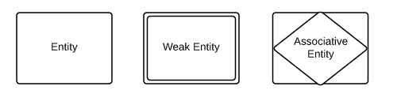

RELATIONSHIPS
- Relationships are meaningful associations between or among entities. They are usually verbs, e.g. assign, associate, or track. A relationship provides useful information that could not be discerned with just the entity types.
- Weak relationships, or identifying relationships, are connections that exist between a weak entity type and its owner.
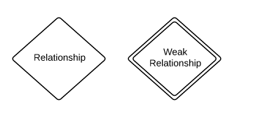

ATTRIBUTES
- Attributes are characteristics of either an entity, a many-to-many relationship, or a one-to-one relationship.
- Multivalued attributes are those that are capable of taking on more than one value.
- Derived attributes are attributes whose value can be calculated from related attribute values.
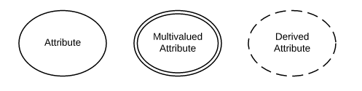

ERD Notation
- Relationships illustrate an association between two tables. In the physical data model, relationships are represented by stylized lines.
- Cardinality and ordinality, respectively, refer to the maximum number of times an instance in one entity can be associated with instances in the related entity, and the minimum number of times an instance in one entity can be associated with an instance in the related entity. Cardinality and ordinality are represented by the styling of a line and its endpoint, as denoted by the chosen notation style.
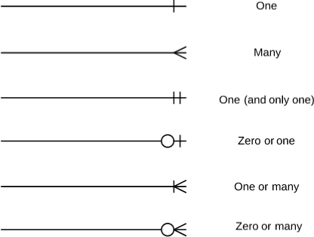
When it comes to notation, data modelers have many options to choose from. While crow's foot notation is widely accepted as the most intuitive style, some developers use OMT, IDEF, Bachman, or UML notation to indicate cardinality. Since crow's foot notation shows both minimum and maximum cardinality in an easy-to-read graphic format, Lucidchart offers crow's foot notation as the preferred style.
Questions:
- Why there is no change when we create the one to one relationship on non-identifying or identifying relationships in IDEF1X Notation.
- How to change from IDEF1X Notation to crow’s feet Notation or to the relational.
- Can’t we make one to one relationship on identifying relationship?

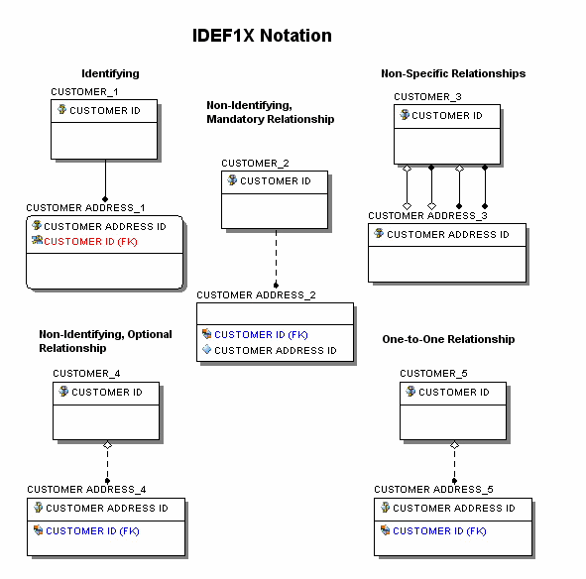

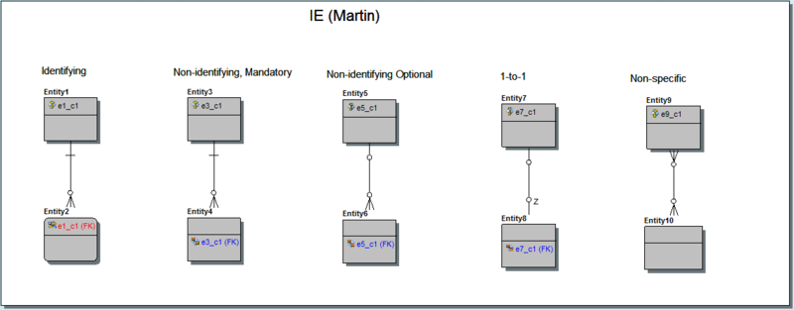

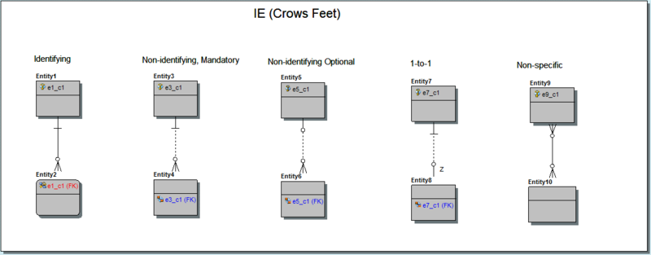

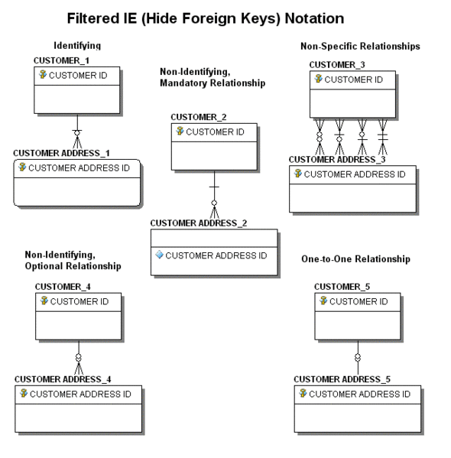
MOLAP --LOAD ALL THE ROWS TO SSAS LEVEL(IT WILL SHOW US THE DATA BASED ON THE TIME WE PROCESS THE CUBE)
ROLAP--IT WILL SHOW THE REAL TIME DATA (NO NEED TO SCHEDULE BUT PERFORMANCE IS NOT GOOD AS IT WILL LOAD THE ALL DATA FROM DB WHEN WE BROWSE)
HOLAP--COMBINATION OF MOLAP AND ROLAP
1- FOR HOLAP ALL THE DIMENSION DATA COMING FROM ROLAP
2- FOR HOLAP ALL THE MEASURES WILL COME FROM MOLAP

Query to Get Metadata In Erwin:

SELECT lower(TRAN(E.PHYSICAL_NAME)) AS 'Table Name',
lower(TRAN(A.PHYSICAL_NAME)) AS 'Column Name',
lower(TRAN(A.PHYSICAL_DATA_TYPE)) AS 'Data Type',
lower(Tran(NULL_OPTION_TYPE)) 'Null Option Type',
lower(Tran(A.Comment)) 'Column Comment'
FROM M0.ENTITY E INNER JOIN M0.ATTRIBUTE A ON E.ID@ = A.OWNER@
ORDER BY 1,A.column_order

